A Business Data Management Study of Customer Demand and Operational Challenges at Metro Hotel and Restaurant, Singur

A Mid Term report for the BDM capstone Project

Submitted by

Name: SAMPRIKTA MALIK
Roll number: 21F3002038



IITM Online BS Degree Program,
Indian Institute of Technology, Madras, Chennai
Tamil Nadu, India, 600036
Contents Page
- Executive Summary 3
- Proof of Originality of the Data 3
- Metadata and Descriptive Statistics 4
      - Metadata 4
      - Descriptive Statistics 5
- Detailed Explanation of Analysis process/method 8
- Results and Findings 9

Declaration Statement
I am working on a project titled “A Business Data Management Study of Customer Demand and Operational Challenges at Metro Hotel and Restaurant, Singur.” I extend my sincere appreciation to Metro Hotel and Restaurant, Singur, for providing the necessary information and cooperation that enabled me to undertake this project.
I hereby assert that the data presented and assessed in this project report is genuine and precise to the utmost extent of my knowledge and capabilities. The data has been gathered through primary sources and carefully analyzed to assure its reliability.
Additionally, I affirm that all procedures employed for the purpose of data collection and analysis have been duly explained in this report. The outcomes and inferences derived from the data are an accurate depiction of the findings acquired through thorough analytical procedures.
I am dedicated to adhering to the information of academic honesty and integrity, and I am receptive to any additional examination or validation of the data contained in this project report.
I understand that the execution of this project is intended for individual completion and is not to be undertaken collectively. I thus affirm that I am not engaged in any form of collaboration with other individuals, and that all the work undertaken has been solely conducted by me. In the event that plagiarism is detected in the report at any stage of the project's completion, I am fully aware and prepared to accept disciplinary measures imposed by the relevant authority.
I agree that all the recommendations are business-specific and limited to this project exclusively, and cannot be utilized for any other purpose with an IIT Madras tag. I understand that IIT Madras does not endorse this.

Signature of Candidate: 
Name: SAMPRIKTA MALIK
Date: 06/03/2026

Executive Summary
This project studies the sales performance of Metro Hotel and Restaurant, a family-run food business located in Singur, Hooghly, West Bengal. Established in 1997, the restaurant operates as a Business-to-Consumer (B2C) establishment, offering dine-in and takeaway services to local residents, office workers, and visitors. It serves affordable and quality food such as rice dishes and biriyani, and runs with 6 to 8 staff members managing daily operations.
The analysis is based on one month of primary sales data collected directly from the restaurant’s billing records. The dataset includes day-wise and item-wise details such as quantity sold, price, and total revenue. Microsoft Excel tools like pivot tables, descriptive statistics, and charts are used to organize and analyze the data. The study focuses on identifying peak sales days, high-demand food items, and the revenue contribution of each menu item to overall income.
The findings show that sales vary across the week. Wednesday generates the highest revenue, while Saturday records comparatively lower sales. Veg Rice is the highest-selling item, followed by Chicken Biriyani and Egg Roll. A few key items contribute a major share of the monthly income.
Overall, the study provides practical insights that help improve inventory planning, staffing decisions, and revenue management to support better business performance.
Proof of Originality of the Data
As part of the proof of originality of the data collected for this project, the following supporting documents are provided:
- Letter of Confirmation from the Restaurant Owner
- Photographs of the Restaurant
- Video Recording of Interaction with the Owner
All supporting documents, including the confirmation letter, photographs, and video recording, are securely uploaded in a Google Drive folder for review:
https://drive.google.com/drive/folders/1Igwt0BO0KUFhnwDjanOWQ2_s8nNRzq_F?usp=sharing
In the video includes regional language communication, an English transcript is attached in the same folder for clarity and academic reference.
Metadata and Descriptive Statistics
Metadata
For this project, the study collects primary sales data from Metro Hotel and Restaurant, a family-run food business located in Singur, Hooghly, West Bengal. The dataset includes daily item-wise sales records and raw-material purchase records for one month of restaurant operations. The restaurant owner provides the data based on manual billing records, and the study enters and organizes the data in Microsoft Excel for analysis.
The purpose of collecting this data is to analyze sales patterns, identify peak demand days, determine high-selling items, and evaluate revenue contribution of menu items to support better revenue and inventory planning.
Dataset Description
The dataset contains the following variables:
Item_sales Sheet
This sheet contains day-wise item-level sales data, including Date, Day, Item Name, Category, Quantity Sold, Price, and Total.
Day – A categorical variable that indicates the day of transaction (Monday to Sunday). This variable helps identify peak sales days and weekly demand patterns.
Item Name – A categorical variable that lists different food items sold by the restaurant (Veg Rice, Chicken Biriyani, etc.). This variable supports item-wise demand analysis.
Category – A categorical variable that groups food items into different categories. This helps in category-level analysis.
Quantity Sold – A numerical variable that shows the number of units sold for each item per day. This variable plays an important role in identifying high-demand items.
Price – A numerical variable that indicates the selling price of each item. This variable helps calculate revenue generated from each item.
Total – A derived numerical variable calculated using the formula: (Total = Quantity Sold × Price) This variable measures revenue contribution and overall business performance.
Data Analysis Tools
The study uses Microsoft Excel to organize and analyze the data. It applies formulas, pivot tables, and charts to summarize and interpret the information.
This approach helps identify the busiest days of the week, high-demand items, and overall revenue contribution. The analysis provides clear insights that support better business decision-making.
The metadata:
https://docs.google.com/spreadsheets/d/1eypB-QSIfJvth_GfrCPvlGM_J5CZbzbt/edit?usp=sharing&ouid=100986144672693162215&rtpof=true&sd=true
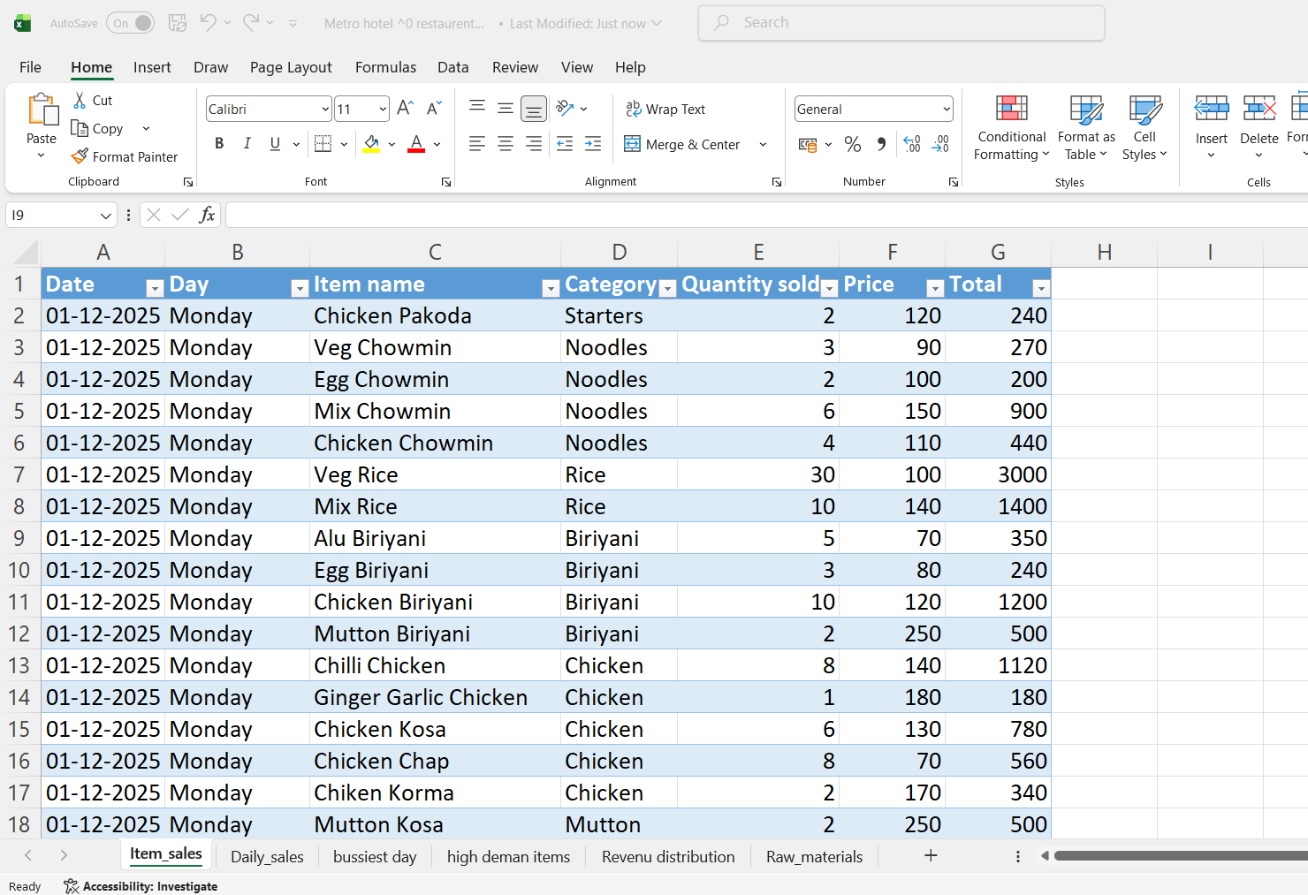
Descriptive Statistics
This section presents a statistical summary of the monthly sales data collected from Metro Hotel and Restaurant. The objective is to summarize overall performance, identify peak demand days, and evaluate item-wise contribution to revenue.
1. Overall Sales Performance
- Total Monthly Revenue: ₹ 4,58,105
- Average Daily Revenue: ₹ 14,777.58
- Highest Revenue (Single Day): ₹ 21,440
- Lowest Revenue (Single Day): ₹ 10,920
- Highest Revenue Date: 24-12-2025 (Wednesday)
- Lowest Revenue Date: 06-12-2025 (Saturday)
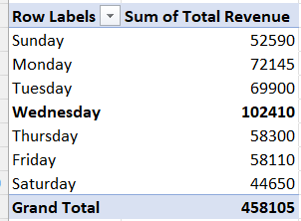
Figure 1:Pivot Table Showing Day-wise Total Revenue
During the observed period, the restaurant generated a total revenue of ₹ 4,58,105. The average daily revenue was ₹ 14,777.58, indicating stable daily earnings. However, revenue fluctuated between ₹ 10,920 and ₹ 21,440, showing variations in customer demand across different days.
2. Day-Wise Sales Analysis
- Total Quantity Sold: 4,200 units
- Busiest Day (Highest Quantity Sold): Wednesday – 926 units
- Lowest Sales Day: Saturday – 438 units
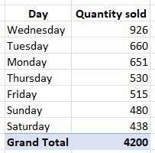
Figure 2: Pivot Table Showing Day-wise total quantity sold
The analysis shows that Wednesday recorded the highest quantity sold (926 units), making it the peak demand day. In contrast, Saturday recorded the lowest sales (438 units). This indicates that mid-week demand is stronger compared to weekends, which is useful for staffing and procurement planning.
3. Item-Wise Sales Analysis
The total quantity sold across all menu items during the month was 4,200 units.
- Highest Selling Item (Quantity): Veg Rice – 899 units
- Second Highest: Chicken Biriyani – 385 units
- Third Highest: Egg Roll – 369 units
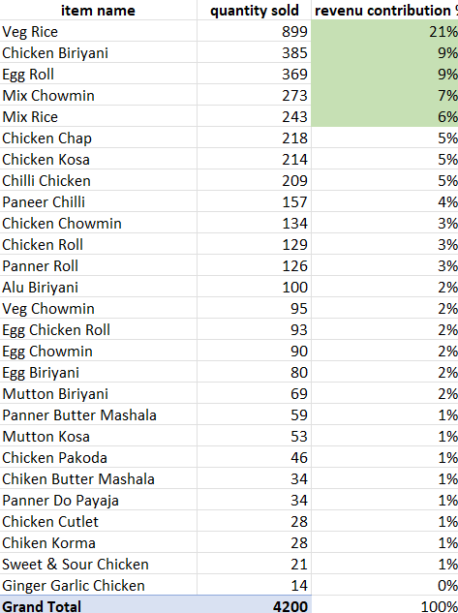
Figure 3:Pivot Table Showing Item-wise Quantity Sold
Veg Rice alone contributed approximately:
$(899÷4200)×100≈21.4$%
This means Veg Rice accounts for about 21% of total quantity sold, making it the most demanded item.
Other popular items include Chicken Biriyani, Egg Roll, and Mix Chowmin, indicating strong demand for both rice-based and roll-based dishes.
4. Demand Pattern Observation
Further observation shows:
- On Wednesday, Veg Rice demand is significantly high.
- On Sunday, Egg Roll and Mix Chowmin show higher demand.
This indicates that customer preferences vary across days, suggesting the need for day-wise inventory planning.
Detailed Explanation of Analysis process/method
This section explains the methods used to analyze the sales data and why these methods suit the identified business problems.
1. Use of Pivot Tables
This analysis uses pivot tables to organize and summarize the sales data in a clear and simple way. The dataset includes categories such as Day and Item Name, along with numerical values like Quantity Sold and Total Revenue. Pivot tables help group and total this information efficiently.
For the problem Identifying Peak Sales Days to Improve Revenue, pivot tables calculate total revenue and total quantity sold for each day. This helps identify the highest and lowest sales days.
For the problem Identifying High-Demand Food Items for Better Inventory Management, pivot tables calculate the total quantity sold for each item. This helps rank food items based on customer demand.
Pivot tables improve the analysis because they:
- Automatically total large amounts of data
- Reduce calculation errors
- Allow quick comparison between days and items
- Make sales patterns easier to understand
Therefore, pivot tables provide an efficient and reliable method for this study.
2. Use of Percentage Contribution Analysis
This analysis calculates percentage contribution to solve the problem Analyzing Revenue Contribution of Menu Items.
The formula used is:
Revenue Contribution (%)
(Item Revenue ÷ Total Revenue) × 100
Percentage contribution clearly shows how much each item adds to total revenue. Simply looking at revenue numbers does not clearly show the importance of each item. This method highlights the relative contribution of every menu item.
This approach helps to:
- Identify top-performing items
- Understand which items generate more income
- Support better pricing and menu decisions
Compared to simply listing revenue amounts alone, percentage analysis provides clearer business understanding.
3. Use of Descriptive Statistics
This analysis uses basic descriptive statistics such as total revenue, average daily revenue, highest revenue, and lowest revenue.
The main objective of this study is to understand current sales patterns rather than predict future sales. Since the dataset contains past transaction records, calculating totals and averages helps identify trends and demand patterns clearly.
Descriptive statistics provide a simple and effective way to summarize the data and support decision-making.
4. Use of Graphical Representation
This analysis uses bar charts and pie charts to present the data clearly.
Bar charts compare day-wise sales and help identify peak and low-demand days.
Pie charts show item-wise revenue contribution and highlight high-performing menu items.
Visual representation makes patterns easier to understand. Charts improve clarity compared to tables alone and support better business decision-making.
Results and Findings
This section presents the key findings obtained from the sales data analysis.
1. Day-wise Total Revenue
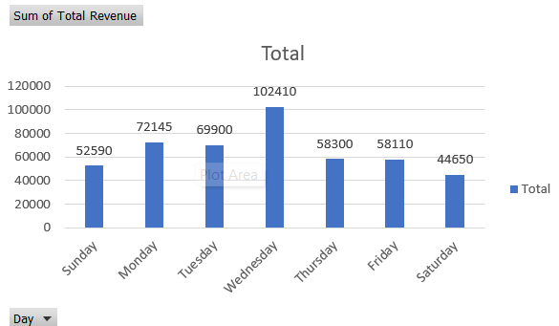
Figure 4:A Bar Chart (Clustered Column Chart) compares day-wise total revenue.
The clustered column chart presents total revenue generated on each day of the week. The analysis shows clear variation in sales performance across different days.
Wednesday records the highest total revenue, indicating peak customer demand. In contrast, Saturday shows comparatively lower sales.
This variation suggests changes in customer footfall during the week. Higher revenue days reflect stronger demand and increased quantity sold.
Business Insight:
The restaurant can:
- Ensure sufficient stock of raw materials
- Introduce offers or discounts on low-demand days
This analysis directly supports revenue planning and operational efficiency.

2. Item-wise Quantity Sold

Figure 5:A Bar Chart displays item-wise total quantity sold.
The bar chart shows total quantity sold for each menu item during the month. The comparison clearly identifies high-demand and low-demand food items.
Veg Rice records the highest quantity sold, indicating strong customer preference. Items with lower quantities reflect comparatively weaker demand.
The variation in quantity sold highlights differences in customer choices and popularity of menu items.
Business Insight:
The restaurant can:
- Maintain adequate stock for high-demand items
- Monitor low-selling items for possible improvement
- Focus marketing efforts on popular products
This analysis helps strengthen inventory management and reduces the risk of stock shortages.

3. Item-wise Revenue Contribution

Figure 6:A Pie Chart presents percentage contribution of top 6 revenue-generating items.
The pie chart illustrates the percentage contribution of top 6 item and others to total monthly revenue. The distribution shows that certain items contribute a larger share of overall revenue.
Veg Rice records for the largest percentage of total revenue. This indicates that the item plays a significant role in business profitability.
Some items contribute less revenue due to lower demand.
Business Insight:
The restaurant can:
- Focus on high-revenue items to maximize profitability
- Review pricing strategies if necessary
- Design promotional offers around top-performing items
Revenue contribution analysis helps identify profit-driving menu items.
Summary:
The analysis shows that sales do not remain the same throughout the week. Some days bring higher revenue, while other days record lower sales.
Certain days attract more customers and generate more income. These days require better planning in terms of staff availability and stock preparation.
The study also shows that some food items sell much more than others. These popular items contribute a large share of total revenue and play an important role in the restaurant’s earnings.
Overall, these findings help the restaurant make smarter decisions about managing raw materials, setting prices, and planning promotions.

